

# Group Project

# World Tourism Guide

**CIS 5611: Client-Side Internet Resource University of Central Missouri**

**By Team Jaguars**

**Methuku Manisha Reddy 700741377 Noothi Vinun Kumar– 700741380**

**Sanka Sree Naga Chandra Sekhara Sai- 700743504**

**Fall 2022**

**Description**:

This project is a World Tourism Guide website where user can view details about the places where they can travel throughout the world and plan accordingly. The website consists of 8 html pages that cover concepts of HTML, CSS, JavaScript, XMLs, JSON, AJAX and jQuery. There is no Database connection or server-side validations on the website. It covers the concepts that are discussed in class for Client-Side Internet Resource.

**Home Page (Part1)**:

After opening home page with Live Server.

Home page covers the HTML concepts including CSS Styles and JavaScript(icon), it shows the basic outline of the site. Below are the usages in this page

* Home HTML Page consists of Header (Includes other pages links).
* Linking to CSS and other HTML Pages.

**Technologies Used:**

* HTML
* CSS

**Page Name**: Home.html

f

**Home Page (Part2)**:

After scrolling down we can see below layout with images of different places from different countries in Home Page.

* When Hover to each image will increase the image size. (External Hover)
* When Clicked on each image will redirect to the official Tourism Site of the specific Country.

**Technologies Used:**

* HTML
* CSS

**Page Name**: Home.html

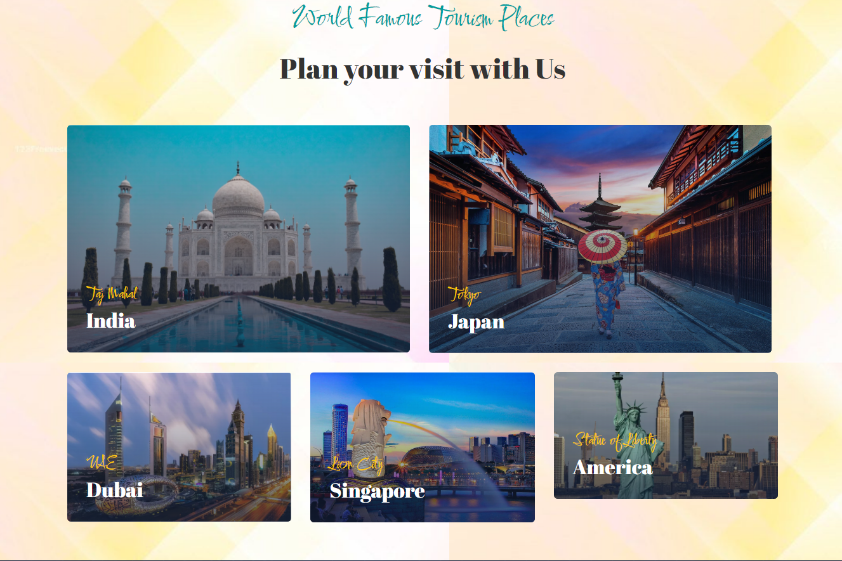

**Home Page (Part3: This part is applicable for all the Pages on the website)**:

Footer of the page consists below layout which has different sections under which different details are provided.

* If we click on About Us(Example) it will redirect to the About Us page(Likewise to other pages included in Quick links).
* If the user wants to subscribe the application, they can provided there email in the block provided and then click subscribe.
* Below right corner we have different icons when clicked will redirect to the specific official sites(Example: Instagram).
* Icons were fetched by using Javascript.

**Technologies Used:**

* HTML
* CSS
* JavaScript

Page Name:All HTML Pages(Home, About Us, Tours.html, Destinations, Blog, Contact Us, Jaguars Team, Booking Now)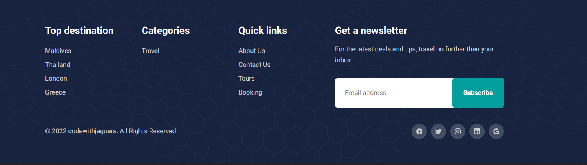

**About Us Page**:

After selecting About Us in Header of any Page in site it will direct to About Us page which looks like below and has below mentioned functionality.

* It has basic information of the site
* Styles are done through CSS.
* After moving the mouse on to the text Explore the world tour with us will load the site decsription content(This was achieved by loading XML using jQuery).

**Technologies Used:**

* HTML
* CSS
* JavaScript(jQuery).
* XML

**About Us Page before**, File Names: About Us.html, AboutUsXML(JQuery).js, AboutUs.xml

**About Us Page after**, File Names: About Us.html, AboutUsXML(JQuery).js, AboutUs.xml

**Tours Page**:

After selecting Tours in Header of any Page in site it will direct to Tours page which looks like below and has below mentioned functionality.

* It shows trip packages for few trips(Exampls: Jordan) which includes, no.of days, prices, rating etc.
* Styles are done through CSS.

**Technologies Used:**

* HTML
* CSS
* JavaScript.

**Tours Page** , File Names: Tours.html.

**Destinations Page**:

After selecting Destinations in Header of any Page in site it will direct to Destinations page which looks like below and has below mentioned functionality.

* Styles are done through CSS.
* When we click on the text “Click here to view the country Highlights” it will load the country pictures and its highlights content.(This is achieved by loading JSON file using jQuery).

**Technologies Used:**

* HTML
* CSS
* JavaScript(jQuery).
* JSON

**Destinations Page before**, File Names: Destinations.html, DestinationsJS.js, destinations.json.

**Destinations Page after**, File Names: Destinations.html, DestinationsJS.js, destinations.json

**Blog Page**:

After selecting Blog in Header of any Page in site it will direct to Blog page which looks like below and has below mentioned functionality.

* Styles are done through CSS.
* It shows blog template of few sample and when click on read more it will direct to recent travel blog official pages.

**Technologies Used:**

* HTML
* CSS
* JavaScript(jQuery).

**Blog Page** , File Names: Blog.html.

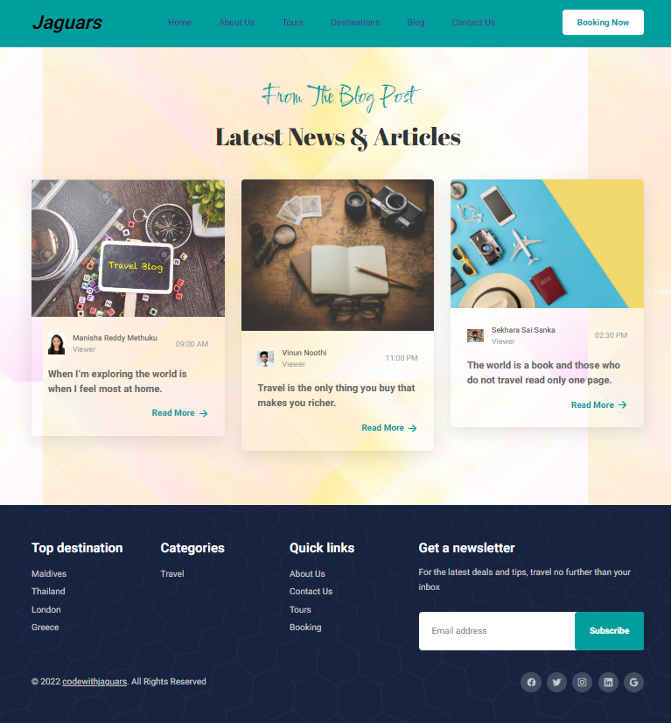

**Contact Us Page**:

After selecting Contact Us in Header of any Page in site it will direct to Contact Us page which looks like below and has below mentioned functionality.

* Styles are done through CSS.
* It has image right after header which reduces its size after page load.(This was done through javascript by using animate()).
* After Image it has a form in which user need to fill the details as a form of survey/review and submit.
* When we click on the text “Click here to viewour details ” it will load the phone number and email address information.(This is achieved by loading XML file using Ajax).

**Technologies Used:**

* HTML
* CSS
* JavaScript(Ajax).
* XML

**Contact Us Page before**, File Names: Contact Us.html, ContactUsXML(Ajax).js and ContactUs.xml.

**Contact Us Page after**, File Names: Contact Us.html, ContactUsXML(Ajax).js and ContactUs.xml.

**Jaguars Team Page**:

After selecting Jaguars in Header of any Page in site it will direct to Jaguars page which looks like below and has below mentioned functionality.

* Styles are done through CSS.
* It shows Jaguars Team members details and displays there information.

**Technologies Used:**

* HTML
* CSS

**Jaguars Team Page**, File Names: Team Details.html

**Booking Now Page**:

After selecting Booking Now in Header of any Page in site it will direct to Booking Now page which looks like below and has below mentioned functionality.

* Styles are done through CSS.
* It has form to plan your trip in which details needs to be filled by user.
* When submitting the details in form and clicking on it will load the confirmation that the details are submitted(No data validation since we do not have any database/server side connections and the coonfirmation is just a hard coded functionality )(This is achieved by loading JSON file using Ajax).

**Technologies Used:**

* HTML
* CSS
* JavaScript(Ajax).
* JSON

**Booking Now Page before**, File Names: Booking Now.html, BookingNowJS.js and BookingNow.json.

**Booking Now Page before**, File Names: Booking Now.html, BookingNowJS.js and BookingNow.json.

